Карточка №1.

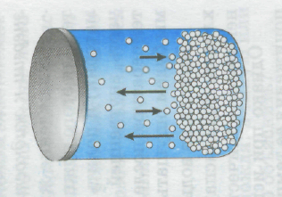

Требование к модели атома
________________________________________________________________________________________________________________________________________________________________________________________________________________________________________________________________________________________________________________________________________________________________________________________________________________________

Карточка №2.

НСl + NaOH = NaСl + Н₂О.

Требование к модели атома
________________________________________________________________________________________________________________________________________________________________________________________________________________________________________________________________________________________________________________________________________________________________________________________________________________________

Карточка №3.

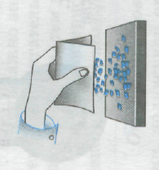
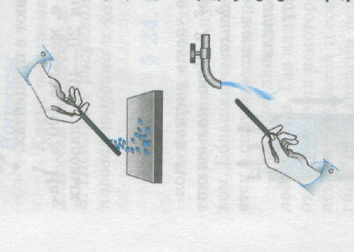

Требование к модели атома
_________________________________________________________________________________________________________________________________________________________________________________________________________________________________________________________________________________________________________________________________________________________________________________________________

Карточка №4.

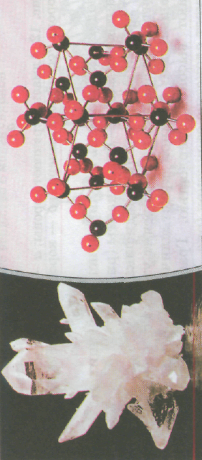

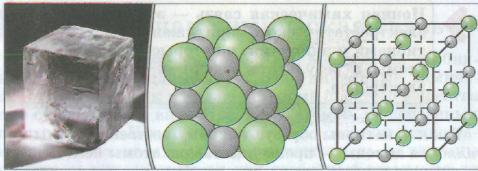
Требование к модели атома
________________________________________________________________________________________________________________________________________________________________________________________________________________________________________________________________________________________________________________________________________________________________________________________________________________________________________________________________

Карточка №5.

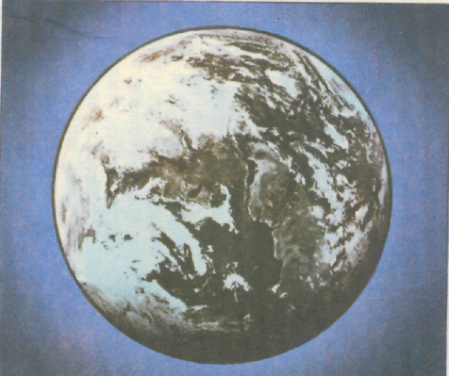
Требование к модели атома
_________________________________________________________________________________________________________________________________________________________________________________________________________________________________________________________________________________________________________________________________________________________________________________________________

