Тренировочные упражнений по грамматике английского языка
К учебнику Н.И.Быковой, Дж.Дули, В.Эванс « Spotlight»(3 класс)

Сборник включает упражнения на отработку грамматического материала по программе 3 класса. Все задания сформулированы на русском языке, чтобы обеспечить точность их понимания. Выполнение этих упражнений обеспечивает не только знание , но и, что более важно, закрепление навыков грамотной речи. В конце сборника дается объяснение соответствующих грамматических явлений.

Составитель: Женетль Г.Т.
учитель английского языка МБОУ СОШ №52,г.Краснодара

Pronouns
(местоимение)
Личное местоимение.
№ 1
Write “he”, “she”, “it” or “ they”( замените слова личными местоимениями).
1.

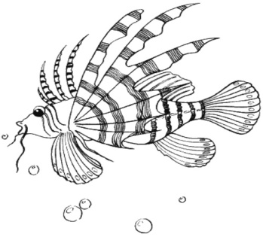- It
2.
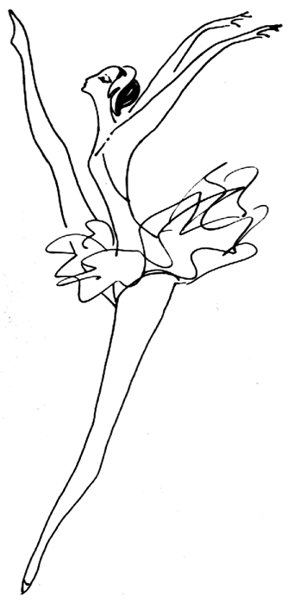 -?
3.
-?
4.
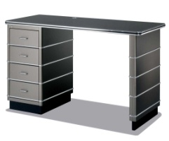-?

5.
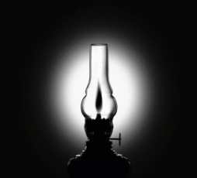 -?
6.
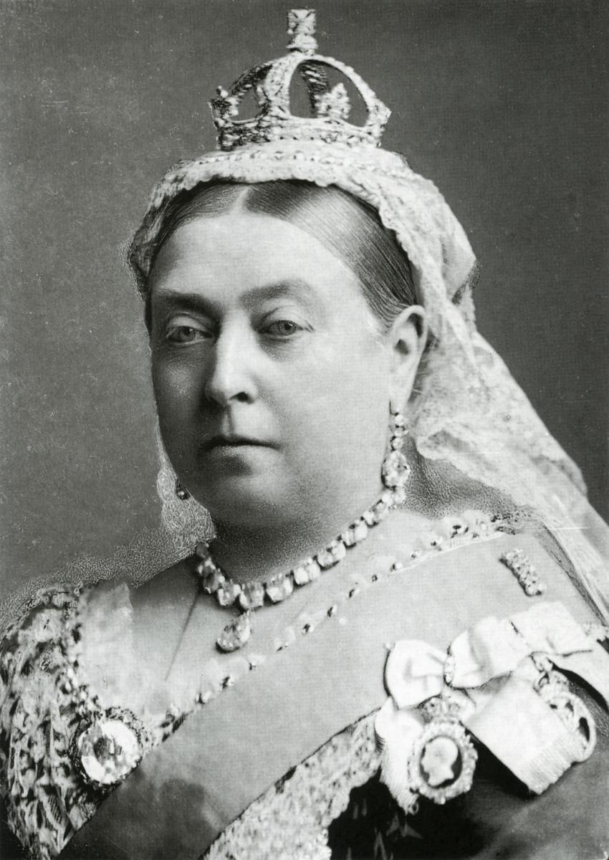 -?
7.
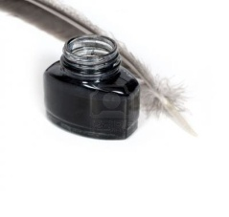 -?
8.
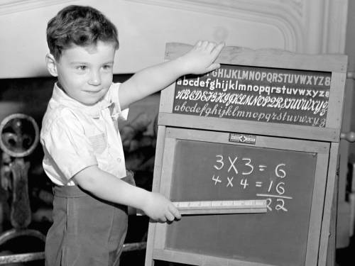 -?
9.
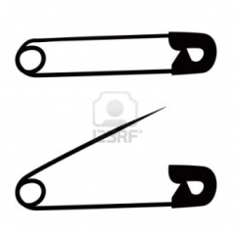 -?
10.
-?

11.

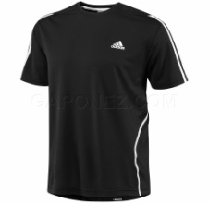-?
12.
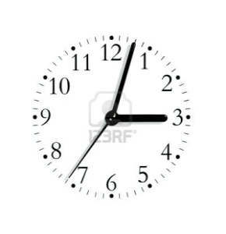-?
13.
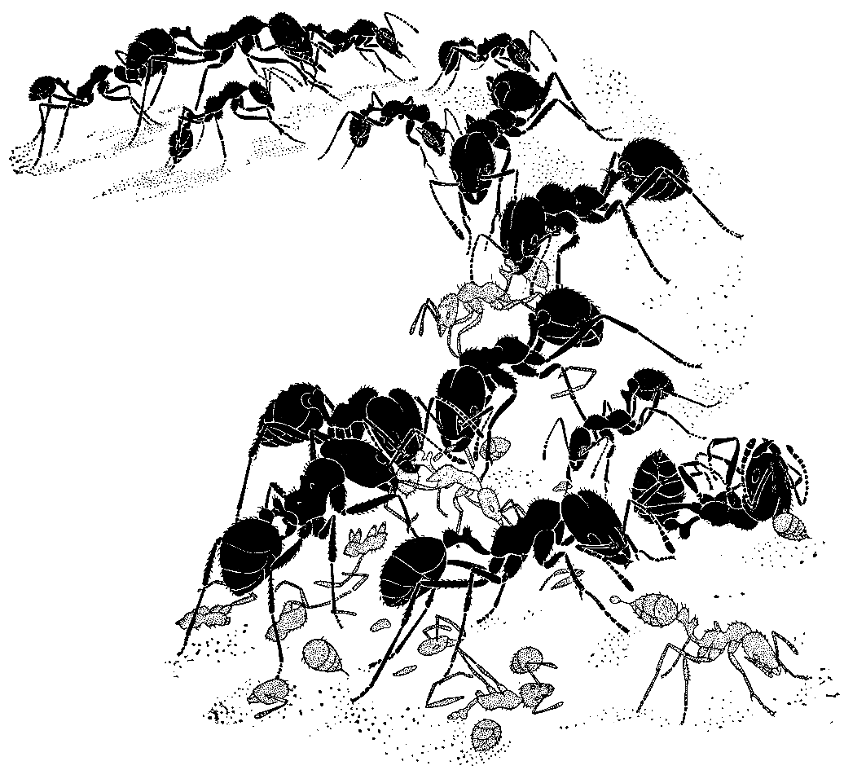 -?
14.
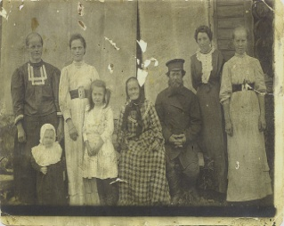 -?
15.
-?

16.
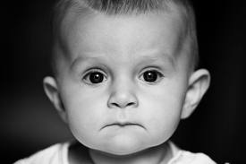 -?

17.
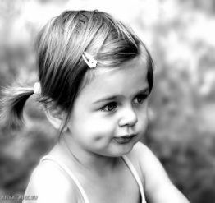 -?

18.
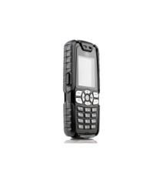-?
19.
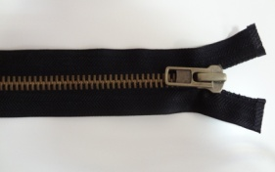 -?

20.
-?
№2
Fill in “he”, “she”, “we”, “it”, “you”, “they” as in the example:( вставьте местоимения как показано на примере).
- A skirt- it
- Flowers-
- Beach-
- A tree house-
- A bath-
- Parties-
- Lulu and Larry-
- Nanny Shine-
- Apples-
- Food-
- Dan, Pam and Ron-
- Chuckles-
- A Clown-
- A Circus-
- A Magician-
- A Frog-
- Fish-
- A Ballerina-
- A Puppet-
- A Jack-in-the-box-
№ 3
Write pronounces “he”, “she”, “it”, “they”(замени слова местоимениями).
- My bed-
- Her dog-
- His glass-
- Her lamp-
- Her umbrella-
- His rabbit-
- My mummy-
- My daddy-
- My school-
- His children-

№4
Write pronounces “he”, “she”, “it”, “they”(замени слова местоимениями).
1. girls-
2. Chuckles-
3. Nanny Shine-
4. Larry’s sister-
5. Lulu and Larry-
6. Grandma and grandpa-
7. a game-
8. matchboxes-
9. mouse-
10. boys-

№5
Write pronounces “he”, “she”, “it”, “they”(замени слова местоимениями).
- Bird house-
- Garden gnome-
- Box telephone-
- Footprints-
- Radio and TV set-
- Houses-
- Friends-
- Village-
- Bubbles-
- Family-

№ 6
Fill in the blanks and answer the questions as in the example:( вставьте нужное местоимение и ответьте на вопрос как показано в примере).
- Look at them!
Are they frogs? 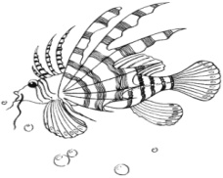

No, they aren’t.
They are fish.
- Look at … .
Is he a pupil? 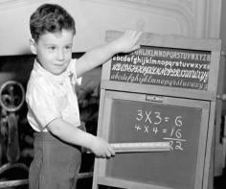
… .
- Look at … .
Is it a flower?
… .
- Look at … .
Are they birds? 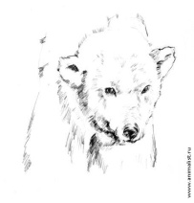
… .
- Look at … .
Are they socks?
… .

- Look at … .
Are they boys?
… .

- Look at … .
Is she a dancer?
… .
- Look at … .
Is she a child?
… .

- Look at … .
Is it a family?
… .

- Look at … .
Is it a fish?
… .

№ 7
Choose and fill in the right personal pronoun in the sentences (выбери и вставь правильное личное местоимение) .
- … am a pupil.
- you b) she c) I
- … are grandfathers.
- he b) they c) we
- … is a school bag.
- he b) she c) it
- This is … friend.
- he b) my c)her
- This is … playroom.
- She b) her c)you
- These are…rocking horses.
- he b) they c) our
- It’s … nursery school.
- our b) it c) us
- … a runner.
- us b) he c) his
- … is a theatre.
- It b) she c)he
- … is a famous poet.
- we b) he c) he

Притяжательное местоимение.
№ 8
Read and circle (прочти и обведи правильный вариант).
1. His/Our name is Larry.
2. Are you/ your names Lulu and Paco?
3. Its/ his name is Chuckles.
4. Look at the children. They/there are Sam, Paco and Jenny.
5. Is her/ his name Nanny Shine
№ 9
Fill in the right pronoun(вставь правильное местоимение в предложение).
- Lulu is a little girl. This is … doll.
- Chuckles is a monkey. This is … banana.
- Nanny Shine is a woman. This is … hat.
- Larry is Lulu’s sister. This is … telephone.
- Larry is a nice boy. This is… book.
№ 10
Fill in the right pronoun(вставь правильное местоимение в предложение).
- What is … name? My name is …Nanny Shine.
- What is … name? Our names are Larry and Lulu.
- What is … name? Its name is Chuckles.
- What is … name? Her name is Liz.
- What is … name? His name is Alex.

№ 11
Fill in the right pronoun(вставь правильное местоимение в предложение).
- It is Chuckles. It is … ball.
- She has got two children. These are… sons.
- She is my grandma. This is … hat.
- Larry is there. That is … T shirt.
- This isn’t Lulu’s jacket. … jacket is yellow.

№ 12
Fill in the right pronoun(вставь правильное местоимение в предложение).
- That bag is … (I)
- These tortoise is …(Anita).
- It is … food.(dog)
- The violin is … (Simon).
- When is … birthday(William).
- … shoes are black(Samuel and William).
- The box of chocolate is …(chuckles).
- Those flowers are …(Granny).
- That skirt is …(Kate).
- Are those cards… (Harry and Tom).

Указательное местоимение
№ 13
- This toy-
- That teddy-bear
- This picture-
- This boat-
- This island-
- That skirt-
- That ruler-
- That camp-
- This T-shirt
- This puppet-
№14
1. This pencil case-
2. This school bag-
3. That subject-
4. This chicken-
5. This carrot-
6. That seahorse-
7. That present-
8. That rabbit-
9. This cooker-
10. That cow-
№15
- This foot-
- This woman-
- This child-
- That boy-
- That goose-
- That man-
- This tooth-
- This fish-
- This mouse
- That sheep-
№16
- This girl is nice.
- That man is my dad.
- This woman is my mummy.
- That child is my little brother.
- This goose is white.

This is / These are…

№17
Fill in(вставьте) : This is /These are
- … my pens.
- … my friend’s computer.
- … the girls’ tortoises.
- … the boys’ spiders.
- … farmer’s sheep.
- … mother’s tea set.
- … father’s room.
- … children’s presents.
- … my kite.
- … sister’s crocodile.

№ 18
Употребите выделенные слова в форме множественного числа. Не забудьте при этом изменить указательные местоимения и форму глагола.
- This girl is my sister
- That toy is on the shelf.
- This child is not a pupil.
- This man is my uncle.
- That boy is my friend.
- This parrot is yellow and green.
- That school is not old.
- This room is lovely.
- This desk is not big.
- That spider is on the wall.

№19
Find and correct the mistake(найди и исправь ошибки)
- I have got a sister. These are my sister’s toys.
- He often sees that children at the stadium.
- Rose is Terry’s mother. That is her flowers.
- Tanya has many toys. This is her musical boxes.
- Billy has ten trains. That is his trains.
- Whose is the rocking horse? That is my rocking horse.
- This is my sister. These are her lamp.
- Mary is Susan’s friend. That is her toys.
- Look! These are her computer and that is my phone.
- That is Larry’s train and those are Lulu’s ball.

Множественное число существительных.

№20
Fill in the plural as in the example(поставь слова во множественное число, как показано в примере):
- One doll-two dolls
- One dolphin-five…
- One bus-seven…
- One fox-eleven…
- One family- four…
- One leaf-six…
- One loaf-three…
- One piano-nine…
- One toy-ten…
10.One clown-fourteen…
11. one dress-five…
12. one witch- nine…
13. one photo-seven..
14. one brush-three…
15. one fly- four…
16. one boy-sixteen…
17. one child- two…
18. one fridge- eighteen…
19. one rubber-twenty…
20. one duck-thirteen..

№ 21
Make plural form(поставь слова во множественное число):
- A baby 11. A fish
- Babys a) fishes
- Babies b) fish
- A man 12. Juice
a) men a) -
b) mans b) juices
c) man c) juics
3. A boy 13. Ice-cream
a) boys a) ices-cream
b) boies b) ice-creams
c) boyes c) -
4. A mouse 14. Banana
a) mouses a) bananas
b) mice b) bananaes
c) mouss c) banans
5. A fox 15. A goose
a) foxs a) goose
b) foxes b) gooses
c) fox c) geese
6. Money 16. Sugar
a) moneys a) sugars
b) – b) sugares
c) moneies c)-
7. A pencil 17. Bread
a) pencils a) breads
b) penciles b) -
8. An umbrella 18. A shirt
a) umbrellas a) shirts
b) umbrells b) shirtes
с) umbrellas c)-
9. A foot 19. A woman
a) foots a) womens
b) feet b) women
c) footes c) womans
10. A sheep 20. A housewife
a) sheep a) housewifes
b) sheeps b) housewives

№23
Write the words in the plural and in the correct column(напиши слова во множественном числе в правильную колонку).
Party banana story lady monkey ice cream child wife
Deer pupil ant umbrella baby mouse ox tooth
Ball sheep radio goose sandwich man

-s | -es | -ies | -ves
 |  | Parties

№24
Change to the plural( во множественное число):
- It is a nice dolphin.
- It is a monkey.
- She is a good boy.
- He is a clown.
- She is a magician.
- He is a soldier.
- She is a ballerina.
- It is a jacket.
- It is a puppet.
- It is a teddy bear.
№25
Fill in the blanks with “a”, “an”, “some”.
1….bread 11. …doll
2….flag 12. … cheese
3….butter 13. …milk
4….coffee 14. …circus
5….coca-cola 15. …rubber
6….meat 16. …sister
7….shirt 17. …jelly
8….apple 18. …tea set
9… cake 19. …pasta
10….money 20. …desk
№26
- Pass me … butter, please.
- some b) a c) an
- There is … jelly on the table.
- a b)an c) some
- There are… grapes in the vase.
- an b) some c) a
- Put … the flour in the bowl.
- a b) an c) some
- Put … milk to the glasses.
- a b) an c) some

- There is … train under a chair.
- some b) a c) an
- There is … computer on the table.
- some b) a c) an
8. There is … tortoise in the box.
a) a b) an c) some
9. There are … flowers in the vase.
- some b) a c) an
- Put … spoon in the box.
- some b) a c) an
№27
Fill in the gaps with: some or any.
- Chuckles wants… bananas.
- Have you got… jam?
- I don’t have … butter in the fridge.
- There are … oranges on the table.
- I want … candles for Larry’s cake.
№
- There is … apples on the table.
- There aren’t … potatoes in the fridge.
- Are there … books on the shelf?
- Are there … birds in the fridge?
- There are … girls in the garden.
- There isn’t … Coke in the fridge.
- Are there … pancakes on the plate?
- Are there … cookies in the box?
- There aren’t … beans in the tin.
- Is there … coconut for us?
Предлоги
№ 28
Fill in at, in, on.
- … Thursday
- … March
- … 2003
- … 5 a.m.
- … Christmas
- … summer
- … afternoon
- … 7 p.m.
- … night
- … New Year
№29
Choose the correct item
- Children don’t go to school … Sunday.
- On b) at c)in
- Anita always goes to the circus … Saturday afternoon.
- In b) on c) up
- Meg was born … 2005.
- In b) on c)at
- Easter is … the spring.
- In b)on c) at
- The shops close … Friday evening.
a)at b) up c) on

To be-Present or Past Simple.
№ 30
Fill in was, am, is, are or were.
It … Friday afternoon and my family and I … in the garden. We … outside today because it … hot. Yesterday it … cold and it … raining. We … in the house all day. I like Fridays and I … very happy today.
№31
Fill in was, am, is, are or were.
- It … Wednesday evening. Harry and Pam … at the theatre. They … at work an hour ago.
- It … Saturday today. The children … at the circus. They … at the zoo last Saturday.
- It …dinner and she … in the kitchen. She … at work in the morning.
№32
Answer the questions
- Was Larry at home?
- Were children at the zoo?
- Was mother in the shop?
- Were you in London?
- Was Jake at the lake?

Have/has got
№33
Fill in have got or has got.
- The queen … a family.
- The boy … a pen.
- The birds … nests.
- The girl … an umbrella.
- The room … windows.
- Lulu … an orange.
- Grandpa … garden.
- Larry … a tree house.
- Children … many pencils.
- Cats … two feet.
№34
Make up the sentences from these words. Обратите внимание, что глагол должен стоять на втором месте.
- A yellow box, has got, Mummy.
- Granny, a green umbrella, has got.
- Has got, a red vest, Daddy.
- A white horse, Grandpa, has got.
- I and my sister, a tree house, have got.
- Larry and Chuckles, apples, have got.
- Mary, a yellow table, has got.
- Lulu, a green bed, has got.
- Have got, Paco and Jenny, chips.
- Ice cream, children, have got.
№35
Translate this part of the sentence.
- У Лулу есть chocolate.
- У Лари есть orange juice.
- У мамы есть a cake.
- У Чаклза есть a hamburger.
- У Пако есть a glass of milk.
- У Лари и Лулу есть many friends.
- У бабушки есть a dog.
- У дедушки и бабушки есть children.
- У брата и сестры есть mummy and daddy.
- У няни Шайн есть a chimp.
№36
Make up the plurals.
- Lulu has got a puppet.(7)
- Larry has got a jacket-in-the-box.(3)
- Nanny Shine has got a bear.(4)
- Chuckles has got a soldier.(9)
- Lulu and Larry have got toys.(10)
- My brother and his friend have got shorts.(2)
- My aunt has got a hat. (5)
- My granny has got a coat.(6)
- Sally and Jerry have got jeans.(8)
- This boy has got socks.(3)
№37
Ask the question to the sentence.
- I have got an umbrella.
- We have got a big house.
- You have got a teddy bear.
- She has got a ballerina.
- He has got a toy soldier.
- They have got wooden souvenirs.
- She and her friend have got all kinds of clothes.
- I and my family beautiful garden.
- A girl has got a pink watch.
- A crocodile has got a green tail.
№38
Ask the questions and fill in Has/ Have got.
- … they got a ruler?
- … he got a pair of compasses?
- … she got flowers?
- …you got holiday?
- … we got pet?
- …Larry got jelly?
- …Paco got medals?
- … Nanny Shine got honey?
- … Chuckles kangaroo?
- … mouse a lamp?
№39
Make up the questions and sentences from these words.
- Has, cheese, got, Sally?
- Sam and Larry, got, ship, have.
- Chuckles, got, a puppet, has?
- Nanny Shine and Lulu, pins, got, have?
- Jenny and Sally, holiday, have, got.
- Poca and Emmy, got, have, garden gnome?
- Their mum, fruit, got, has.
- Their family, got, a country house, has.
- We, got, have, a, nice, family.
- You and she, have, a green house, got?
№40
Translate it into English.
- У меня есть папа и мама.
- У нее есть бабушки.
- У моего друга есть радио.
- Есть у твоего брата лошадь?
- Есть у Дженни кенгуру?
- В нашем доме есть дымоход.
- У вас в доме есть дымоход?
- У Лари в доме есть лестница.
- Есть у тебя в доме лестница?
- У Лулу есть брат.
№ 41
Ask the questions
- He has got ants.
… ants?
- I have got fish.
… fish?
- We have got friends.
… friends?
- She has got chicks.
… chicks?
- You have got a ship.
…a ship?
- They have got rabbits.
… rabbits?
- He and she have got yachts.
… yachts?
- I and he have got dogs.
… dogs?
- Sam has got a snake.
… a snake?
- Samuel and Sam have got boxes.
… boxes?
№ 42
Вырази свое удивление: Неужели?
For example:
She has a ship.
- Has she?
I have a car.
- Have you?
1.He has a white dolphin.
1. He has got a white dolphin.
2. It has got ten crocodiles.
3. She has got nine houses.
4. We have got seven villages.
5. Larry and Lulu have got three kangaroos.
6. Chuckles has got a white tree.
7. My house has got four kitchens.
8. My Grandpa has got two country houses.
9. This mouse has got eight mice.
10. Her friends have got six yachts.

№ 43
First say and then write questions and answers as in the example:
(сначала скажи, а затем напиши вопросы и ответы, как показано в примере)

 | Some trains | A parrot | A computer | A tea set | A mac
Paco
Nanny Shine
Lulu
Larry
You

- What has Paco? He has got some trains, a parrot, a computer. He hasn’t got a tea set and a mac.
- What has…?
- What has …?
- What has …?
- What have you got? …

№ 44
Possessive s’/’s
- Liz/ ruller
- The roof/ the house
- The rabbits/ the cage
- Charles/ the book
- A bird/ a nest
- Those men/ the cars
- My parents/ the friends
- King Charles 2nd/ the portrait
- Tom and Sally/ dogs
- My sister/pineapple

Грамматический справочник.
Pronounces
Personal pronouns
( личные местоимения)
ставиться перед глаголам ставиться после глагола
I  я | Me  Мне
He  он | Him  Ему
She  она | Her  Ей
It  Он, она ,оно | Its  ему, ей
You  Ты, вы | You  Тебе, вам
We  мы | Us  Нам
They  они | Them  им
Who? (кто) /What (что)? | Whom (кому)?

Possessives
( притяжательные местоимения)

За местоимением стоит существительное. | За местоимением нет существительного.
My-мой | Mine
His/her/its-его/ ее/ | His/hers/-
Our-наше | Ours
Your-твое, ваше | Yours
Their-их | Theirs

Указательные местоимения
This is…  Это… | These are…  Эти…
That is…  Тот… | Those are…  Те…

- this/ these употребляются, когда говорится о находящихся вблизи людях, животных или предметах или указывают на них.
This is a lamp.
These are lamps.
- that/ thoseупотребляются, когда говорится о находящихся вблизи людях, животных или предметах или указывают на них.
That is an elephant.
Those are birds.

Местоимения Some/ Any
Some
- Употребляется с неисчисляемыми существительными в утвердительных предложениях.
There is some sugar in the cup.
- Употребляется в утвердительных предложениях с исчисляемыми существительными во множественном числе.
There are some apples on the table.
- Употребляется в вопросительных предложениях, обозначающих просьбу.
Can I have some juice, please?
Any
- Употребляется с неисчисляемыми существительными в отрицательных
и вопросительных предложениях.
There aren’t any water in the fridge.
Is there any milk in the glass?
Prepositions of time
(предлоги времени)
AT
Время праздники выражения
At 5 o’clock At Christmas At noon
At night
At weekend

IN
Выражения
In the morning
In the afternoon
In the evening
ON
Дни недели
On Monday
On Tuesday
On Wednesday…

Plurals
(Формы множественного числа).
- Большинство существительных образуют форму существительного путем добавления –s.
- К существительным оканчивающимся на – ch; -sh; -ss;-s; -o ;-x
во множественном числе добавляется –es.
A fox-foxes
A musical box-musical boxes
A dress-dresses
A glass-glasses
A potato-potatoes
A match-matches
A watch-watches
A brush- brushes
!REMEMBER(ЗАПОМНИ!) : RADIO-RADIOS
PIANO-PIANOS
PHOTO-PHOTOS
VIDEO-VIDEOS
- К существительным, оканчивающимся на гласную + y, добавляется-s
A toy-toys
A boy-boys
- У существительных оканчивающихся на согласную + y , во множественном числе заменяется на-i и добавляется-es.
a baby-babies
a fly- flies
- У существительных, оканчивающихся на-f или -fe ,во множественном числе заменяется на -v и добавляется –es.
A wife-wives
A wolf-wolves

Множественное число.
Исключения

Единственное число | Множественное число
A man | Men
A woman | Women
A child | Children
A tooth | Teeth
A foot | Feet
A mouse | Mice
A fish | Fish
A sheep | Sheep

Some nouns are uncountable. They have no plural:
Bread | Cheese | Jam | Milk
Lemonade | Tea | Juice | Coca-cola
Butter | Coffee | Meat | Sugar
Money | Water | Wood | Paper
Possessive case
(притяжательный падеж существительных)

- Показывает принадлежность.
Lulu’s doll
- Образуется с помощью ‘s( апостроф и s).
The dog’s house
- Чтобы узнать, кому что-либо принадлежит, задается вопрос, начинающийся со слова whose.
Whose is this pen?

Конструкция There is/ There are
Конструкция There is/ There are употребляется для сообщения о наличии в данном месте какого-либо лица или предмета.
- there is употребляется с существительными в единственном числе. Краткой формой there is является there’s.
There is(there’s) an apple on the table.
- there are употребляется с существительными во множественном числе
There are two windows in the living room.
Вопросительная форма:
Is there…( ед.ч.) ?
Are there…(мн.ч.) ?
Is there a desk in your room?
Are there a lot of people in the park?
Отрицательная форма:
There is not(isn’t)…
There are not(aren’t)…
There is not(isn’t) a dish on the table.
There are not(aren’t) two sandwiches in the lunch box.

Глагол “ to be”
(быть, находиться, являться)
Утвердительная форма:
Полная форма | Краткая форма
I am | I’m
He is | He’s
She is ед.ч. | She’s
It is | It’s
We are | We’re
They are мн.ч. | They’re
You are | You’re

Вопросительная форма:
Am I …?
Is he…?
Is she…?
Is it…?
Are we…?
Are they…?
Are you…?

Отрицательная форма:
Полная форма | Краткая форма
I am not | I’m not
He is not | He isn’t
She is not | She isn’t
It is not | It isn’t
We are not | We aren’t
They are not | They aren’t
You are not | You aren’t

Краткие ответы:
В кратких ответах используется Yes или No. В кратких ответах мы не повторяем весь вопрос, a используем только Yes или No , личное местоимение( I, he, she..) и глагол am(am not), is(isn’t), are (aren’t).
Are you a pilot?
Yes, I am /we are.
No, I am not/we aren’t.

Глагол have/has got
(иметь)
Употребляется, чтобы:
- показать принадлежность чего-либо кому-либо.
My mum has a nice hat.
- описывать людей, животных или предметы.
It’s got a big nose.

Утверждение |  | Вопрос
Полная форма | Краткая форма
I  We HAVE  You GOT  They  She HAS  He GOT  It | I’ve got | Have I got…?
 | We’ve got | Have we got …?
 | You’ve got | Have you got …?
 | They’ve got | Have they got…?
 | She’s got | Has she got …?
 | It’s got | Has it got…?
 | He’s got | Has he got …?

Отрицание
Полная форма | Краткая форма
I have not got | I haven’t got
We have not got | We haven’t got
They have not got | They haven’t got
You have not got | You haven’t got
She has not got | She hasn’t got
He has not got | He hasn’t got
It has not got | It hasn’t got

Краткие ответы
В кратких ответах употребляется только Yes или No ,личное местоимение в именительном падеже( I, she, he, we,you…) и глагол have(haven’t)/ has (hasn’t).
Have you got a sister?
Yes, I have (we have) ./ No, I haven’t (we haven’t).
Has a hare big ears? Yes, it has.

Past Simple
( прошедшее простое время)
To be
- В вопросительных предложениях was/were ставится перед подлежащим ( I, we, she he..).
Was he a t the party?
- В отрицательных предложениях после was/were ставиться not.
He was not at the party.

Утверждение | Вопрос
I was | Was I?
He was | Was he?
She was | Was she?
It was | Was it?
We were | Were we?
They were | Were they?
You were | Were you?

Отрицание
Полная форма | Краткая форма
I was not | I wasn’t
He was not | He wasn’t
She was not | She wasn’t
It was not | It wasn’t
We were not | We weren’t
They were not | They weren’t
You were not | You weren’t

Краткие ответы
- В кратких ответах используется Yes или No, личное местоимение(I, he she, you) и глагол to be в соответствующей форме.
Were you at school?
Yes, I was/we were.
Was she at the cinema?
Yes, she was./
No, she wasn’t.

