TEST

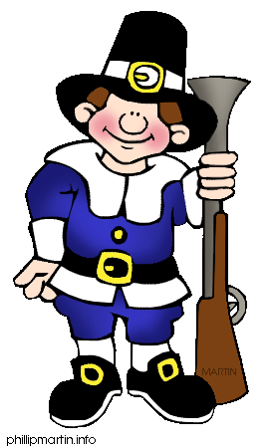
10. Choose the right variant.
1) Thanksgiving Day is
a) a British holiday
b) a Russian holiday
c) an American holiday
2) People celebrate Thanksgiving Day
a) in offices
b) in their houses
c) outdoors
3) When do Americans celebrate Thanksgiving Day?
on the fourth Thursday in November
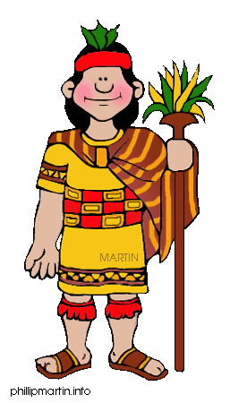
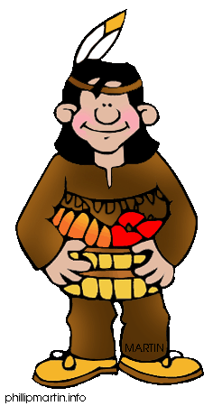
on the fourth Tuesday in November
on the fourteenth of November
4)What is a symbol of Thanksgiving Day?
a) eggs
b) turkey
c) hamburgers
5) People decorate their houses with
a) the lights and balls
b) the toys and sweets
c) the fruit and flowers
6) What vegetables did Indians teach the Pilgrims to grow?
a) tomatoes and cucumbers
b) beans and potatoes
c) peas and carrots
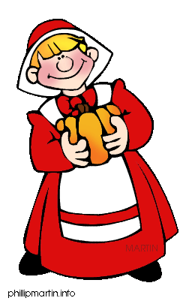
7) What berry is the symbol of Thanksgiving Day?
a) strawberry
b) cherry
c) cranberry
8) When did the Pilgrims come to the new land?
a) in 1621
b) in 1620
c) in 1720
9) What was the name of the Pilgrims' ship?
a) Santa Maria
b) Mayflower
c) Victoria
10) Will people go on Thanksgiving parade, if it is raining?
a) Of course, they will.
b) No, they won't.
c) They will go on the parade on another day.

