Counting Critters

Count the things in each group. Write the number word in the boxes, paying attention to the shapes.
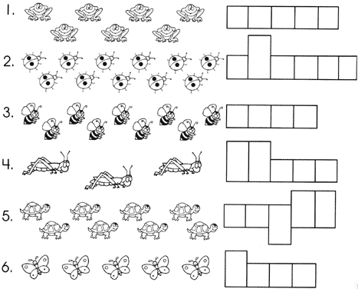

1. one
2. two
3. three
4. four
5. five
6. six
7. seven
8. eight
9. nine
10. ten
11. eleven
12. twelve

Answer Key:
- seven; 2. eleven; 3. nine; 4. three; 5. eight; 6. Five

Spring Poems
Spring  I love the spring.  For every day  There’s something new  That’s come to stay.  Another bud  Another bird  Another blade  The sun has stirred.  My Spring Garden  Here is my little garden,  Some seeds I’m  Going to sow.  Here is my rake  To rake the ground,  Here is my handy hoe.  Here is the big  Round yellow sun,  The sun warms everything.  Here are the rain clouds  In the sky,  The birds will start to sing.  Little plants will  Wake up soon,  And lift their sleepy heads.  Little plants will  Grow and grow  From their warm earth beds.  Spring Is Here  Spring is here,  In the air,  You can smell it coming,  On the trees,  Leaves are green,  Caterpillars sunning.  Birds are back,  Grass is out,  Busy bees are humming,  On the trees,  Leaves are green,  Caterpillars sunning.  Surprise  Close your eyes  And do not peek  And I’ll rub “spring”  Across your cheek.  Soft as velvet  Smooth and sleek  Close your eyes  And do not peek.  Springtime  A small green frog  On a big brown log;  A black and yellow bee  In a little green tree;  A red and yellow snake  By a blue-green lake,  All sat and listened  To red bird sing,  “Wake up, everybody,  It’s spring! It’s spring!”  What the Robin Told  The wind  told the grasses,  And the grasses  told the trees.  The trees  told the bushes,  And the bushes  told the bees.  The bees  told the robin,  And the robin  sang out clear:  Wake up!  Wake up!  Spring is here!  Little Mary  Little Mary was good;  The weather was fair;  She went with her mother  To taste the fresh air.  The birds they were singing;  Mary chatted away;  And she was as happy  And merry as they.  By Eliza Lee Follen | May  May’s a month of happy sounds,  The hum of buzzing bees,  The chirp of little baby birds  And the song of a gentle breeze.  * * *  The grass is green.  Flower blossoms I have seen.  The days are warm.  By evening it cools.  It’s time to find the garden tools.  Spring  Spring makes the world a happy place  You see a smile on every face.  Flowers come out and birds arrive,  Oh, isn’t it grand to be alive?  Kite Flying  On many spring days I wish that I  Could be a kite flying in the sky.  I would climb high toward the sun  And chase the clouds.  Oh, what fun!  Whichever way the wind chanced to blow  Is the way that I would go.  I’d fly up, up, up.  I’d fly down, down, down.  Then I’d spin round and round and round.  Finally I’d float softly to the ground.  Young Lambs  The spring is coming by a many signs;  The trays are up, the hedges broken down  That fenced the haystack, and the remnant shines  Like some old antique fragment weathered brown.  And where suns peep, in every sheltered place,  The little early buttercups unfold  A glittering star or two – till many trace  The edges of the blackthorn clumps in gold.  And then a little lamb bolts up behind  The hill, and wags his tail to meet the yoe;  And then another, sheltered from the wind,  Lies all his length as dead – and lets me go  Close by, and never stirs, but basking lies,  With legs stretched out as though he could not rise.  By John Clare  Who Has Seen the Wind?  Who has seen the wind?  Neither I nor you;  But when the leaves hang trembling  The wind is passing through.  Who has seen the wind?  Neither you nor I;  But when the trees bow down their heads  The wind is passing by.  By Christina G. Rossetti  Springtime  (to the tune of “The Muffin Man”)  Springtime is garden time,  Garden time, garden time,  Get your spades and come outdoors,  Springtime is here!  Springtime is planting time,  Planting time, planting time,  Get your seeds and come outdoors,  Springtime is here!  Springtime is jumping time,  Jumping time, jumping time,  Get your ropes and come outdoors,  Springtime is here!  Springtime is singing time,  Singing time, singing time,  Children sing a happy song,  Springtime is here!  A Child of Spring  I know a little maiden,  She is very fair and sweet,  As she trips among the grasses  That kiss her dainty feet;  Her arms are full of flowers,  The snow-drops, pure and white,  Timid blue-eyed violets,  And daffodillies bright.  She loves dear Mother Nature,  And wanders by her side;  She beckons to the birdlings  That flock from far and wide.  She wakes the baby brooklets,  Soft breezes hear her call;  She tells the little children  The sweetest tales of all.  Her brow is sometimes clouded,  And she sighs with gentle grace,  Till the sunbeams, daring lovers,  Kiss the teardrops from her face.  Well we know this dainty maiden,  For April is her name;  And we welcome her with gladness,  As the springtime comes again...  By Ellen Robena Field

The Giants and the Herd-boy
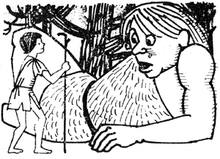
There was once upon a time a poor boy who had neither father nor mother. In order to gain a living he looked after the sheep of a great lord. Day and night he spent out in the open fields, and only when it was very wet and stormy did he take refuge in a little hut on the edge of a big forest.
One night, when he was sitting beside his flocks, he heard the sound of someone crying. He got up and followed the direction of the noise. To his astonishment he found a giant lying at the entrance of the wood.
He was about to run off when the giant called out: “Don’t be afraid – I won’t harm you. On the contrary, I will reward you if you will bind up my foot. I hurt it when I was trying to root up an oak tree.” The herd-boy took off his shirt and bound the giant’s wounded foot with it.
Then the giant got up and said: “Now I will reward you. We are going to celebrate a marriage today, and I promise you we shall have plenty of fun. Come and enjoy yourself, but in order that my brothers may not see you, put this band round your waist and then you’ll be invisible.”
With these words he handed the herd-boy a belt, and walking on in front, he led him to a fountain, where hundreds of giants and giantesses were assembled preparing to hold a wedding.
They danced and played different games till midnight. Then one of the giants tore up a plant by its roots, and all the giants and giantesses made themselves so thin that they disappeared into the earth through the hole made by the uprooting of the plant. The wounded giant remained behind to the last and called out: “Herd-boy, where are you?”
“Here I am, close to you,” was the reply.
“Touch me,” said the giant, “so that you, too, may come with us.”
The herd-boy did as he was told, and before he would have believed it possible, he found himself in a big hall, where the walls were made of pure gold. Then to his astonishment he saw that the hall was furnished with the tables and chairs that belonged to his master.
In a few minutes the company began to eat and drink, and when the youth had eaten and drunk as much as he could, he thought to himself, “Why shouldn’t I put a loaf of bread in my pocket? I shall be glad of it tomorrow.” So he seized a loaf and put it under his tunic.
No sooner had he done so than the wounded giant limped up to him and whispered softly: “Herd-boy, where are you?”
“Here I am,” replied the youth.
“Then hold on to me,” said the giant, “so that I may lead you up again.”
So the herd-boy held on to the giant, and in a few minutes he found himself on the earth once more, but the giant had vanished. The herd-boy returned to his sheep and took off the invisible belt, which he hid carefully in his bag.
The next morning the lad felt hungry and thought he would cut off a piece of the loaf he had carried away from the feast and eat it. But although he tried with all his might, he couldn’t cut off the smallest piece! In despair he bit the loaf, and what was his astonishment when a piece of gold fell out of his mouth and rolled at his feet! He bit the bread a second and third time, and each time a piece of gold fell out of his mouth, but the bread remained untouched.
The herd-boy was delighted over his good fortune, and hiding the magic loaf in his bag, he hurried off to the nearest village to buy himself something to eat. Then he returned to his sheep.
Now, the lord whose sheep the herd-boy looked after had a very lovely daughter who always smiled and nodded to the youth when she walked with her father in his fields. For a long time the herd-boy had made up his mind to prepare a surprise for her on her birthday. So when the day approached, he put on his invisible belt, took a sack of gold pieces with him, and slipping into her room in the middle of the night, he placed the bag of gold beside her bed and returned to his sheep.
The girl’s joy was great, and so was her parents’ next day when they found the sackful of gold pieces. The herd-boy was so pleased to think of the pleasure he had given that the next night he placed another bag of gold beside the girl’s bed.
This he continued to do for seven nights, and the girl and her parents made up their minds that it must be a good fairy who brought the gold every night. But one night they determined to watch and see from their hiding-place who the bringer of the sack of gold really was.
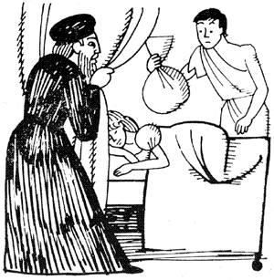
On the eighth night a storm of wind and rain came on while the herd-boy was on his way to bring the beautiful girl another bag of gold. Then for the first time he noticed, just as he reached his master’s house, that he had forgotten the belt which made him invisible. He didn’t like the idea of going back to his hut in the wind and wet, so he just stepped as he was into the girl’s room, laid the sack of gold beside her, and was turning to leave the room, when his master confronted him and said: “You young rogue! So you were going to steal the gold that a good fairy brings every night, were you?”
The herd-boy was so taken aback by his words that he stood trembling before him and did not dare to explain his presence.
Then his master spoke: “As you have always behaved well in my service, I will not send you to prison; but go at once and never let me see your face again.”
So the herd-boy went back to his hut, and taking his loaf and belt with him, he went to the nearest town. There he bought himself some fine clothes and a beautiful coach with four horses, hired two servants, and drove back to his master.
Imagine how astonished he was to see his herd-boy returning to him in this manner!
Then the youth told him of the piece of good luck that had befallen him and asked him for the hand of his beautiful daughter. This was readily granted, and the two lived in peace and happiness ever after.
Compiled by Oscar Weigle

Animals Word Search
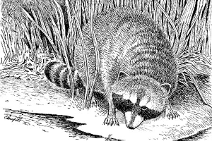
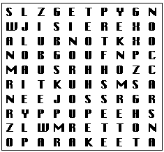
MONKEY  RABBIT  MOUSE  RACCOON  OPOSSUM  ROOSTER  OTTER  SHEEP  PARAKEET  SWAN  PENGUIN  TURKEY  PUPPY |  | 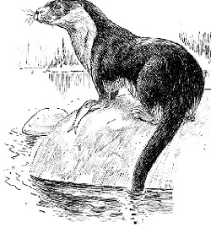

Valentine’s Day Puzzle

Key: Words: heart, candy, flowers, love, cards, cupid. Phrase: Love is in the air.

A Great Find
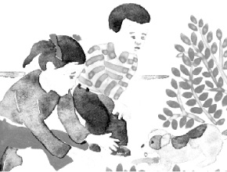
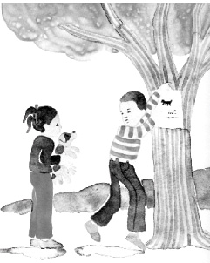
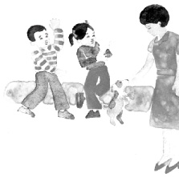
Pat and Sue sat down to watch TV. It was time to see T.R. Shorter. They called him the “Animal Man”. He showed animals and read something about each one. A funny little dog called Caps and a baby goat called Red were on TV with him all the time. The other animals he showed were new each time. This time he showed frogs, rabbits, swans, a seal, and a little doe.
After they saw T.R. Shorter and his animals, the children went out.
“Look, Pat,” said Sue. “There is something over there.”
“Do you know what it is?” said Pat.
“No,” Sue said. “But I want to find out.”
Sue put out her hands to the thing they saw. With a wag and a cry, out danced a soft, little dog with a long tail.
“A dog! A dog!” cried Sue, “We have a dog to play with.”
“Not so fast,” said Pat. “We have to think about this. Number one, this is not your dog and it is not my dog. Number two, Mother will not let us have animals at home. And number three...”
But as Pat said “Number three,” the dog ran down the road.
“Stop! Stop!” called Sue. Then she looked at Pat. “Come on,” she said. “We have to get him back.”
Away they went after the little dog.
“There he is,” called Pat, “under that tree. I think I can get him.”
“Good dog,” said Pat as they came to the tree. “Now do not run away again. We will take you home with us.”
Soon the children were back home.
“How can we get him past Mother?” Sue said to Pat.
“Get what past Mother?” said Mother. She looked at her two children. Then she saw the dog. “You know how I feel about dogs,” she said. “I like dogs, but I do not want to have one at home. This dog will have to go.”
“But it has no place to go,” said Pat.
“You may give the dog something to eat,” said Mother. “But then you have to find out where it came from and take it back.”
Sue went to get the dog something to eat. Then the two children sat down to think.
“I feel bad,” said Sue. “I like this dog.”
“I like him too,” said Pat. “But we have to find out where he came from.”
“How?” said Sue.
“We will write up all we know about the dog,” Pat said. “We will say that he is the color of sand, and that he is little and soft. We will say where he was when we saw him. Then we will put what we write on the highest tree so people will see it.”
“We have to give people a number where they can call us,” Sue said.
“Good,” said Pat. “Now we have to get to work.”
The children worked for a long time. Then they went to the big tree and came back home. But no one called about the dog. At last, Pat and Sue had to go to sleep. The little dog went to sleep too.
“It is time to get up,” called Mother.
“OK,” said Sue.
“Here Dog! Here Dog!” called Sue. The little dog ran over to her. Then she and the dog went to find Pat in the hall.
“Mother will not let us have the dog any longer,” Pat said. “After we see the Animal Man on TV, we will have to find it a new home.”
Sue and Pat sat down to see T.R. Shorter and his animals. As they did, the little dog ran over to the TV.
“Look at the little dog run and wag his tail,” said Pat. “What do you think he would like to tell us?”
“I think he sees T.R. Shorter,” said Sue. “Yes, that is it! This is Caps, the dog that is on TV all the time with T.R. Shorter.”
“We have to let T.R. know we have his dog,” said Pat.
“Yes,” said Sue. “We can call him up.” And that is what they did.
After the children made the call, Mother came in.
“Did you find a home for the dog?” she said.
“Yes!” cried the children. “It is a great home too! It is on TV with T.R. Shorter. This is Caps. He ran out to play and ran away. No one could find him. We called T.R. Shorter, and he said we can be on TV! That is where he would like us to give back the dog.”
“How great!” said Mother. “Do you want to be on TV again, Caps?”
Caps let out a little bark and with a wag of his tail, ran over to Mother.
“I think Caps said ‘Yes,’” Pat said.

How Do Insects Move?
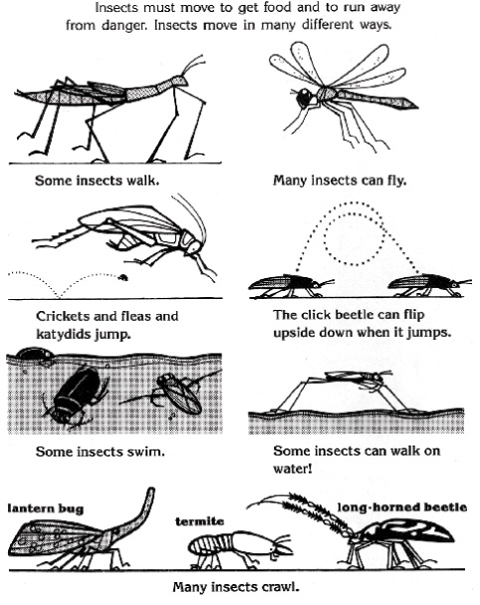

Crossword Fun
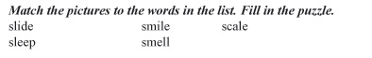
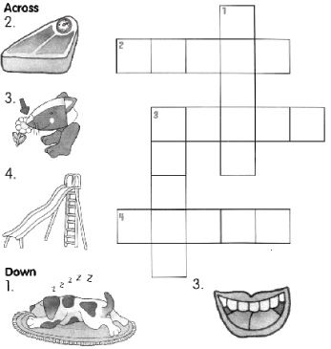

Are You a Good Friend?
I. Try this quiz and find out!
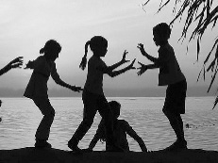
1. Your friend has not done their homework. What do you do?
a) laugh = 0
b) let your friend copy = 3
c) tell the teacher = 0
2. It’s your friend’s birthday. Did you...
a) buy a present = 3
b) say ‘Happy Birthday’ = 1
c) forget = 0
3. Your friend has forgotten his/her lunch. Do you…
a) share yours = 3
b) eat yours in front of them = 0
c) lend them money = 1
4. Your friend calls or texts you while you are watching your favourite TV programme. Do you…
a) ignore the message = 0
b) chat to your friend = 3
c) tell them to call later = 1
5. You get a very good mark in a school test and your friend gets a bad mark. What do you do?
a) help them in the next test = 3
b) say your friend is stupid = 0
c) say never mind = 1
6. You are playing football and your friend falls over. What do you do?
a) run on and score a goal = 0
b) stop and help your friend = 3
c) kick the ball out = 1
7. If you borrow money off a friend do you…
a) forget to pay it back = 0
b) give it back after a while = 1
c) give it back soon = 3
8. A boy/girl you don’t know very well drops their school bag. Do you…
a) help them pick it up = 3
b) kick the bag = 0
c) ignore it = 0
9. Your best friend is on holiday for 3 weeks. Do you…
a) text every day = 3
b) find another friend = 0
c) not think of your friend = 0
10. How many friends do you have?
a) hundreds = 0
b) a big group of friends = 1
c) a few special friends = 3
II. Now calculate your points to find out if you are a good friend!
24–30 points You are a very good friend!
20–23 points You are quite nice to your friends but could help them more!
12–19 points You could be a much better friend if you tried!
1–11 points Have you got any friends

