Проверочная работа по теме «Задача»

1. Прочитать равенства:

3+2=5 6+2=8 4+2=6

4+1=5 3+1=4 4+3=7

Какие из равенств подходят к рисункам?

1).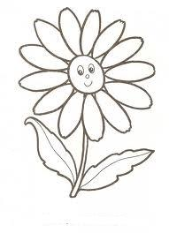 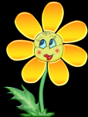

2). 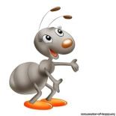 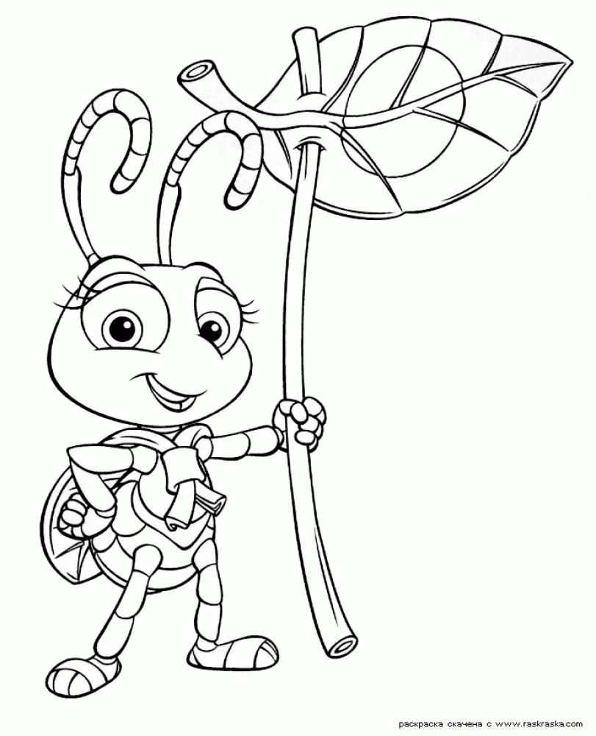



3).

Сделай рисунок к остальным равенствам.

|  |  |  |
| --- | --- | --- |
|  |  |  |

1. Запиши к каждому рисунку подходящую сумму. Найди значение всех сумм.

1).   

|  |  |  |  |  |  |  |  |  |  |  |  |  |  |  |  |  |  |  |  |  |  |
| --- | --- | --- | --- | --- | --- | --- | --- | --- | --- | --- | --- | --- | --- | --- | --- | --- | --- | --- | --- | --- | --- |
|  |  |  |  |  |  |  |  |  |  |  |  |  |  |  |  |  |  |  |  |  |  |
|  |  |  |  |  |  |  |  |  |  |  |  |  |  |  |  |  |  |  |  |  |  |

2) 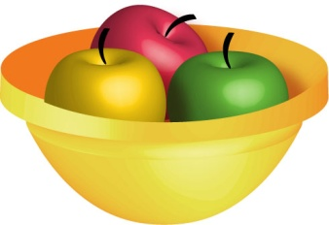 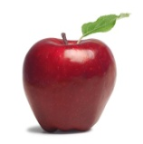

|  |  |  |  |  |  |  |  |  |  |  |  |  |  |  |  |  |  |  |  |  |  |
| --- | --- | --- | --- | --- | --- | --- | --- | --- | --- | --- | --- | --- | --- | --- | --- | --- | --- | --- | --- | --- | --- |
|  |  |  |  |  |  |  |  |  |  |  |  |  |  |  |  |  |  |  |  |  |  |
|  |  |  |  |  |  |  |  |  |  |  |  |  |  |  |  |  |  |  |  |  |  |

3) 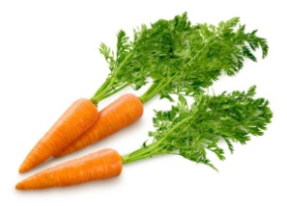

|  |  |  |  |  |  |  |  |  |  |  |  |  |  |  |  |  |  |  |  |  |  |
| --- | --- | --- | --- | --- | --- | --- | --- | --- | --- | --- | --- | --- | --- | --- | --- | --- | --- | --- | --- | --- | --- |
|  |  |  |  |  |  |  |  |  |  |  |  |  |  |  |  |  |  |  |  |  |  |
|  |  |  |  |  |  |  |  |  |  |  |  |  |  |  |  |  |  |  |  |  |  |

1. Реши задачу.

На ветке висело 5 вишенок. Подул ветер, и 2 вишенки упали. Сколько вишенок осталось на ветке?

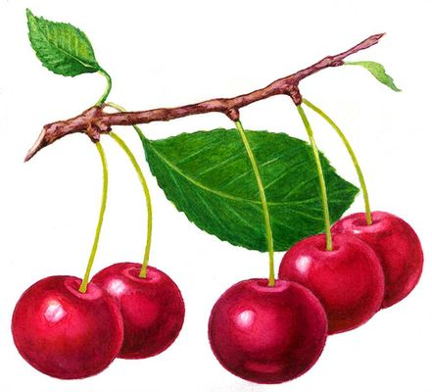

|  |  |  |  |  |  |  |  |  |  |  |  |  |  |  |  |  |  |  |  |  |  |
| --- | --- | --- | --- | --- | --- | --- | --- | --- | --- | --- | --- | --- | --- | --- | --- | --- | --- | --- | --- | --- | --- |
|  |  |  |  |  |  |  |  |  |  |  |  |  |  |  |  |  |  |  |  |  |  |
|  |  |  |  |  |  |  |  |  |  |  |  |  |  |  |  |  |  |  |  |  |  |

1. Реши задачу.

Во дворе гуляли 5 рыжих щенков и 2 белых. Сколько щенков гуляло во дворе?

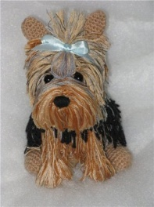

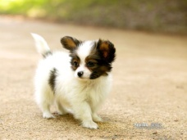

|  |  |  |  |  |  |  |  |  |  |  |  |  |  |  |  |  |  |  |  |  |  |
| --- | --- | --- | --- | --- | --- | --- | --- | --- | --- | --- | --- | --- | --- | --- | --- | --- | --- | --- | --- | --- | --- |
|  |  |  |  |  |  |  |  |  |  |  |  |  |  |  |  |  |  |  |  |  |  |
|  |  |  |  |  |  |  |  |  |  |  |  |  |  |  |  |  |  |  |  |  |  |

1. Составь задачу по рисунку.



                                            
                                            
                                            
                                            