**Упрощение выражений**

1. Упростите выражение .

2. Найдите значение выражения  при 

3.Упростите выражение . 4. Упростите выражение .

5. Найдите значение выражения  при 

6. Найдите значение выражения , если 

7. Упростите выражение .

8. Найдите значение выражения , если , .

9. Упростите выражение .

10. Найдите значение выражения , если , .

11. Упростите выражение . 12. Выполните вычитание .

13. Упростите выражение .14. Упростите выражение .

15. Выполните вычитание . 16. Упростите выражение .

17. Упростите выражение . 18. Сократите дробь .

19. Выполните вычитание дробей .

20. Выполните сложение дробей .

21. Выполните деление дробей .

22. Выполните умножение дробей .

23. Выполните деление дробей .

24. Сократите дробь .

|  |  |  |  |  |  |  |  |
| --- | --- | --- | --- | --- | --- | --- | --- |
| 1) |  | 2) |  | 3) |  | 4) |  |

25. Сократите дробь .

|  |  |  |  |  |  |  |  |
| --- | --- | --- | --- | --- | --- | --- | --- |
| 1) |  | 2) |  | 3) |  | 4) |  |

26. Сократите дробь .

|  |  |  |  |  |  |  |  |
| --- | --- | --- | --- | --- | --- | --- | --- |
| 1) |  | 2) |  | 3) |  | 4) |  |

27. Сократите дробь .

|  |  |  |  |  |  |  |  |
| --- | --- | --- | --- | --- | --- | --- | --- |
| 1) |  | 2) |  | 3) |  | 4) |  |

28. Сократите дробь .

|  |  |  |  |  |  |  |  |
| --- | --- | --- | --- | --- | --- | --- | --- |
| 1) |  | 2) |  | 3) |  | 4) |  |

29. Сократите дробь .

|  |  |  |  |  |  |  |  |
| --- | --- | --- | --- | --- | --- | --- | --- |
| 1) |  | 2) |  | 3) |  | 4) |  |

30. Сократите дробь .

|  |  |  |  |  |  |  |  |
| --- | --- | --- | --- | --- | --- | --- | --- |
| 1) |  | 2) |  | 3) |  | 4) |  |

31. Сократите дробь .

|  |  |  |  |  |  |  |  |
| --- | --- | --- | --- | --- | --- | --- | --- |
| 1) |  | 2) |  | 3) |  | 4) |  |

32. Сократите дробь .

|  |  |  |  |  |  |  |  |
| --- | --- | --- | --- | --- | --- | --- | --- |
| 1) |  | 2) |  | 3) |  | 4) |  |

33. Сократите дробь .

|  |  |  |  |  |  |  |  |
| --- | --- | --- | --- | --- | --- | --- | --- |
| 1) |  | 2) |  | 3) |  | 4) |  |

34. Упростите выражение  .

|  |  |  |  |  |  |  |  |
| --- | --- | --- | --- | --- | --- | --- | --- |
| 1) |  | 2) |  | 3) |  | 4) |  |

35. Упростите выражение .

|  |  |  |  |  |  |  |  |
| --- | --- | --- | --- | --- | --- | --- | --- |
| 1) |  | 2) |  | 3) |  | 4) |  |

36. Упростите выражение .

|  |  |  |  |  |  |  |  |
| --- | --- | --- | --- | --- | --- | --- | --- |
| 1) |  | 2) |  | 3) |  | 4) |  |

37. Упростите выражение .

|  |  |  |  |  |  |  |  |
| --- | --- | --- | --- | --- | --- | --- | --- |
| 1) |  | 2) |  | 3) |  | 4) |  |

38. Упростите выражение  .

|  |  |  |  |  |  |  |  |
| --- | --- | --- | --- | --- | --- | --- | --- |
| 1) |  | 2) |  | 3) |  | 4) |  |

39. Упростите выражение  .

|  |  |  |  |  |  |  |  |
| --- | --- | --- | --- | --- | --- | --- | --- |
| 1) | 2 | 2) |  | 3) |  | 4) | ‑ 2 |

40. Упростите выражение  .

|  |  |  |  |  |  |  |  |
| --- | --- | --- | --- | --- | --- | --- | --- |
| 1) |  | 2) |  | 3) |  | 4) |  |

41. Упростите выражение  .

|  |  |  |  |  |  |  |  |
| --- | --- | --- | --- | --- | --- | --- | --- |
| 1) |  | 2) |  | 3) |  | 4) |  |

42. Упростите выражение .

|  |  |  |  |  |  |  |  |
| --- | --- | --- | --- | --- | --- | --- | --- |
| 1) |  | 2) |  | 3) |  | 4) |  |

43. Упростите выражение  .

|  |  |  |  |  |  |  |  |
| --- | --- | --- | --- | --- | --- | --- | --- |
| 1) | ‑ 3 | 2) | 2 | 3) |  | 4) |  |

44. Выполните сложение дробей . 45. .

46. Выполните вычитание дробей . 47. .

48. Выполните сложение дробей .

49. Выполните сложение дробей .

50. Выполните вычитание дробей .

51. Выполните вычитание дробей .

52. Выполните сложение дробей .

53. Выполните сложение дробей 

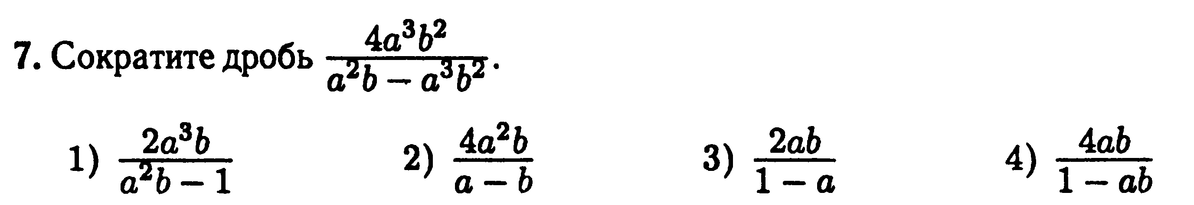

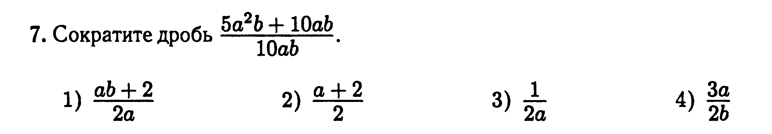

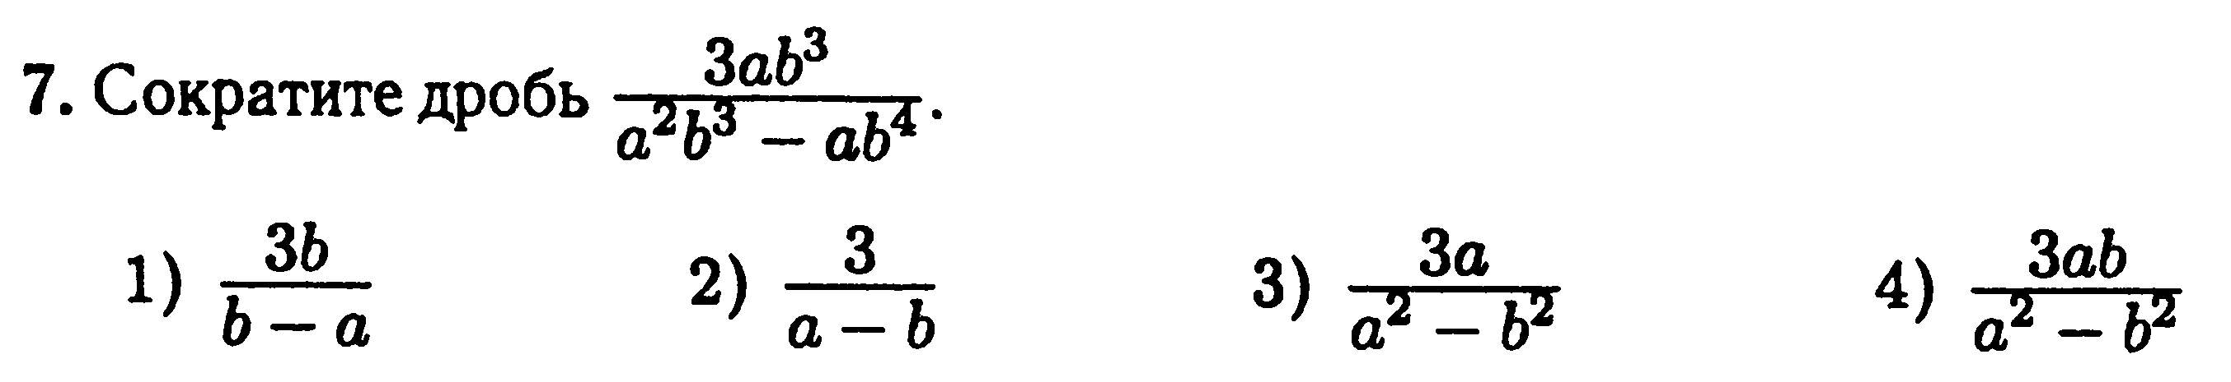

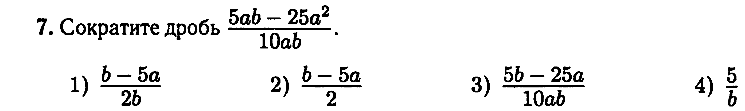

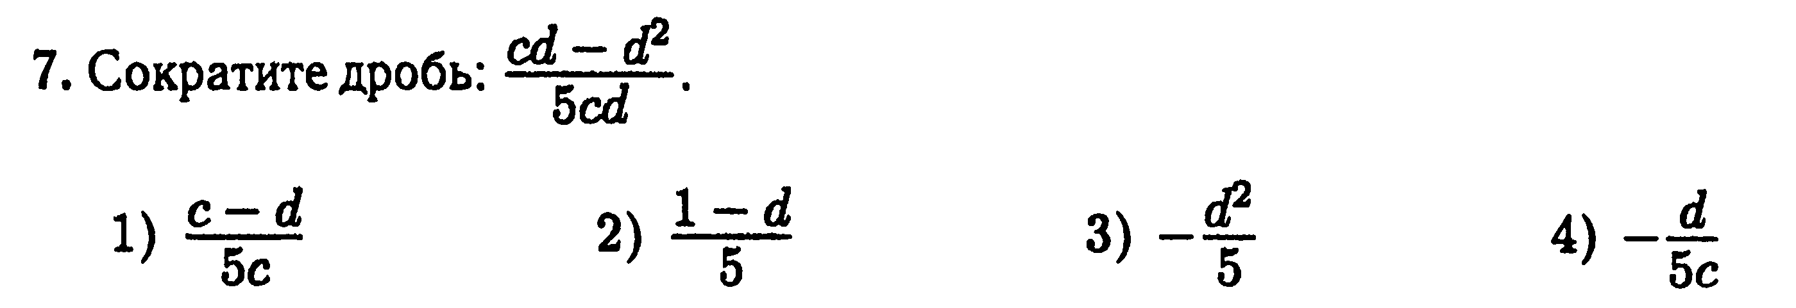

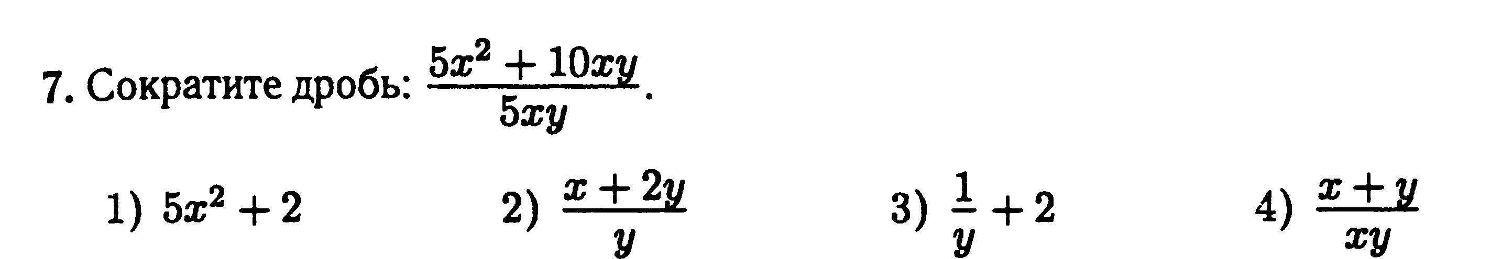

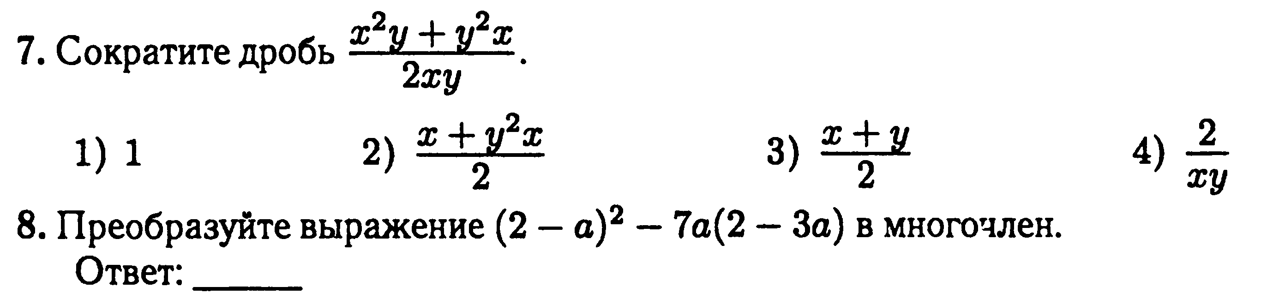

**Вариант 1.** Упростите выражение .

|  |  |  |  |  |  |  |  |
| --- | --- | --- | --- | --- | --- | --- | --- |
| 1) |  | 2) |  | 3) |  | 4) |  |

**Вариант 2.** Упростите выражение .

|  |  |  |  |  |  |  |  |
| --- | --- | --- | --- | --- | --- | --- | --- |
| 1) |  | 2) |  | 3) |  | 4) |  |

**Вариант 3.** Упростите выражение .

|  |  |  |  |  |  |  |  |
| --- | --- | --- | --- | --- | --- | --- | --- |
| 1) |  | 2) |  | 3) |  | 4) |  |

**Вариант 4.** Упростите выражение .

|  |  |  |  |  |  |  |  |
| --- | --- | --- | --- | --- | --- | --- | --- |
| 1) |  | 2) |  | 3) |  | 4) |  |

**Вариант 5.** Упростите выражение .

|  |  |  |  |  |  |  |  |
| --- | --- | --- | --- | --- | --- | --- | --- |
| 1) |  | 2) |  | 3) |  | 4) |  |

**Вариант 6.** Упростите выражение .

|  |  |  |  |  |  |  |  |
| --- | --- | --- | --- | --- | --- | --- | --- |
| 1) |  | 2) |  | 3) |  | 4) |  |

**Вариант 7.** Упростите выражение .

|  |  |  |  |  |  |  |  |
| --- | --- | --- | --- | --- | --- | --- | --- |
| 1) |  | 2) |  | 3) |  | 4) |  |

**Вариант 8.** Упростите выражение .

|  |  |  |  |  |  |  |  |
| --- | --- | --- | --- | --- | --- | --- | --- |
| 1) |  | 2) |  | 3) |  | 4) |  |

**Вариант 9.** Упростите выражение .

|  |  |  |  |  |  |  |  |
| --- | --- | --- | --- | --- | --- | --- | --- |
| 1) |  | 2) |  | 3) |  | 4) |  |

**Вариант 10.** Упростите выражение .

|  |  |  |  |  |  |  |  |
| --- | --- | --- | --- | --- | --- | --- | --- |
| 1) |  | 2) |  | 3) | 2 | 4) |  |