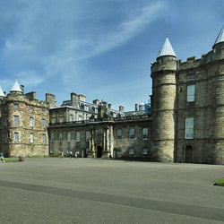
Holyrood Palace
03.11.2010
Holyrood Palace in Edinburgh was the official residence of the British Queen in Scotland. Between Edinburgh Castle and Castle Holyrood lies the so called Royal Mile.

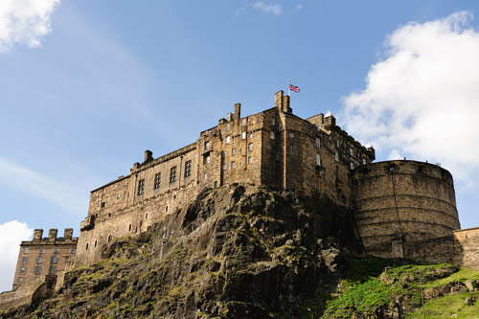Edinburgh castle
Monday, 24 May 2010
Edinburgh castle is the most popular symbol of the Scottish city. Dating back more than 11 centuries this beautiful palace was built on the cliffs of Castle Rock, which tower over the Scottish capital. This place was a perfect location in the past against attacks ranging from Roman times right through to 18th century.

The area was inhabited even before the new record, but the regal fortress existed in the period 9-12 century. In the 9th century it was the royal residence of Malcolm Kenmor and his wife Margarita. In the following centuries it is used as a military fort.
At the beginning of 11th century Edinburgh castle was called, Castle of virgins. The people before the Scottish that lived there give legends that they were the ancestors of Scots. Three centuries later, the most revered Scottish King Robert Bruce commanded to destroy the castle of Edinburgh, so it would not fall into the hands of British troops. After twenty years when Scotland was acquired by independence, Edinburgh castle was restored.
Along with Edinburgh castle is situated the Chapel of Saint Margaret, which is considered the oldest building of the covered territory. Some believe that it was built during the reign of Margaret herself, but others believe it was erected by some of her sons.
For centuries Edinburgh Castle and its history is wrapped with different stories about witches and dramatic events. Near the main entrance it is called, the well for the witches, where more than 300 witches were.
Before the main gate was built the figure of King Robert and his knight William Wallace, who gained worldwide fame with the movie "Braveheart". The Tower of Edinburgh Castle is the place where Queen Margarita grieved when she learned that her son and her husband had fallen in battle with the Norman in 1093. The locals are accustomed to this frightening volley, but guests of the city were usually scared. This tradition still exists since 1861.

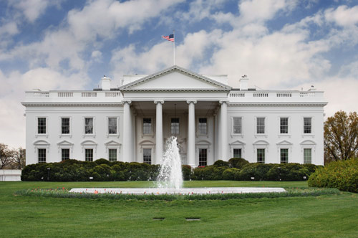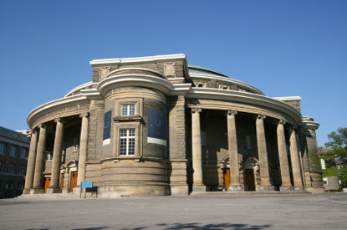Ottawa University

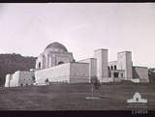 War memorial -Canberra
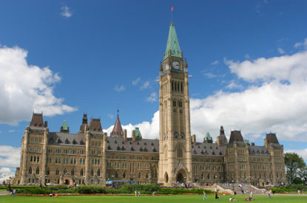Ottawa Parlament
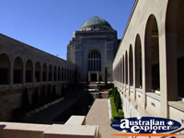Canberra War memorial

Canberra Parlament House

