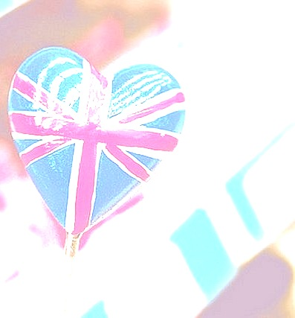
Step3: Where is it?
The London Eye is on the Southbank of river Thames. It's a 5 minute walk from both Waterloo and Westminster Metro Stations.
The mini-quiz.
You should decide if the sentence is true or false and put a cross in the card.
Do you agree or disagree?
1.London is the capital of Spain.
2. Big Ben is a famous street.
3. Buckingham Palace is the home for the Queen.
4. The Thames is the main river in London.
5. London Eye is the monument in London.
6. Queen Elizabeth 2 lives in Westminster Abbey.
7. Trafalgar Square is a popular place for tourists.
8. Piccadilly circus is a square.

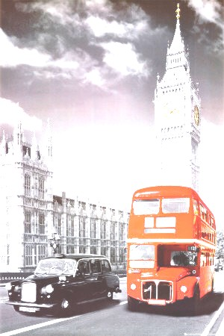
Exercise book.

Faces of london
Name______ Class___

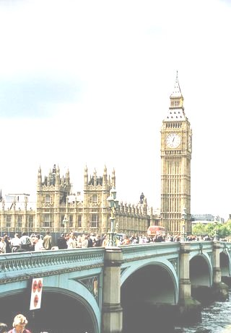
) Постановка проблемы.
Постановка проблемы.
There are different pictures on the blackboard. Look and say how would you formulate the theme of the lesson?

Звучит бой часов Биг Бэн.

Учащиеся читают самостоятельно.
Ex 1. p. 72 (Enjoy English - Биболетова М.З.)

There are different pictures on the blackboard. Look and say how would you formulate the theme of the lesson?

Фонетическая отработка слов.
(подберите названия с картинками на доске)
Trafalgar Square (Nelson's Column)
Buckingham Palace
The Houses of Parliament
Big Ben
The Tower of London (Bloody Tower, White Tower)
Westminster Abbey
Tower Bridge
British Museum
National Gallery
London Eye
The river Thames
Piccadilly Circus
Hamleys
Hyde Park
The Queen
Учащиеся читают самостоятельно.
Ex 1. p. 72 (Enjoy English - Биболетова М.З.)

. Warming up.
Учащиеся отвечают на вопросы учителя.
-What do you know about London?
Is London a city or a town?
-Where is London situated?
-Is it one of the biggest cities in the world? Is it beautiful?
-What can you say about population of London?
-Are you a Londoner?
-Have you ever been to London?
-Would you like to go to London?
What sightseeings of London do you know?
Where do people watch plays?
Where do people watch sporting events?
Where do people watch films?
Where do people see collections of paintings and sculptures?

Проверка домашнего задания.
Let’s check your homework.
What did you do at home?

Работа с дефинициями.
Finish the sentences
1) Big Ben
-palace
-a bell
-a square

2)The queen lives in
- the Tower of London
-Buckingham palace
-Windsor palace

3)The Bloody Tower is in
-The Tower of London
-The Houses of Parliament
-Westminster Abbey

4)The country’s leaders speak in
-The Houses of Parliament
-Big Ben
- Buckingham palace

Развитие навыков чтения.
-Have you ever heard about London Eye?
Ответы учащихся: No, we have not.
Let s learn some new words.
Wheel, the biggest, Windsor Castle, pod,passengers
Ticket, to hire out, Westminster Tube Stations, Waterloo Tube Stations,.
Read the textStep1 History
The London Eye was formally opened by the then Prime Minister, Tony Blair, on 31 December 1999, although it was not opened to the public until 9 March 2000 because of technical problems . It opened in 2000 and was originally going to be a temporary structure to mark the Millennium. The Eye was floated up the Thames in sections and lifted into place by a big crane.
Step2: What is it?
The London Eye is the biggest wheel in the world. It's 135 metres (443 ft) high, and on a clear day you can see all the way to Windsor Castle, which is over 40 km (25 miles) away. It has 32 sections (cabins) and each one holds up to 25 people. Most people buy single tickets, but it is possible to hire out a whole pod. A ride takes 30 minutes, and as the Eye only travels at just under 1 km per hour, passengers get on and off while it is still moving.

Step3: Where is it?
The London Eye is on the Southbank of river Thames. It's a 5 minute walk from both Waterloo and Westminster Metro Stations.

-What place would you like to visit?

I want to visit … because it is …
I want to see … because it is …
I would like to see … because it is …

Use the words: popular, famous, beautiful, interesting, wonderful, old, big.

Динамическая пауза
Up and down, up and down,(поднять руки и опустить)
Which is the way to London town?
Where? Where?
Up in the air,(поднять глаза в потолок)
Close your eyes –(закрыть глаза)
And you are there!

Запись домашнего задания.
Кроссворд о достопримечательностях Лондона.
Do the crossword about the sight seeings of London.

